上學去

Journey to school

在這個專案中，你會訓練電腦從你同學們上學的交通方式裡找出共通的模式。

In this project you will train the computer to look for patterns in how your classmates get to school.

你會讓電腦預測不同人上學的交通方式當作測試

You’ll test this training by getting the computer to predict how different people travel to school.

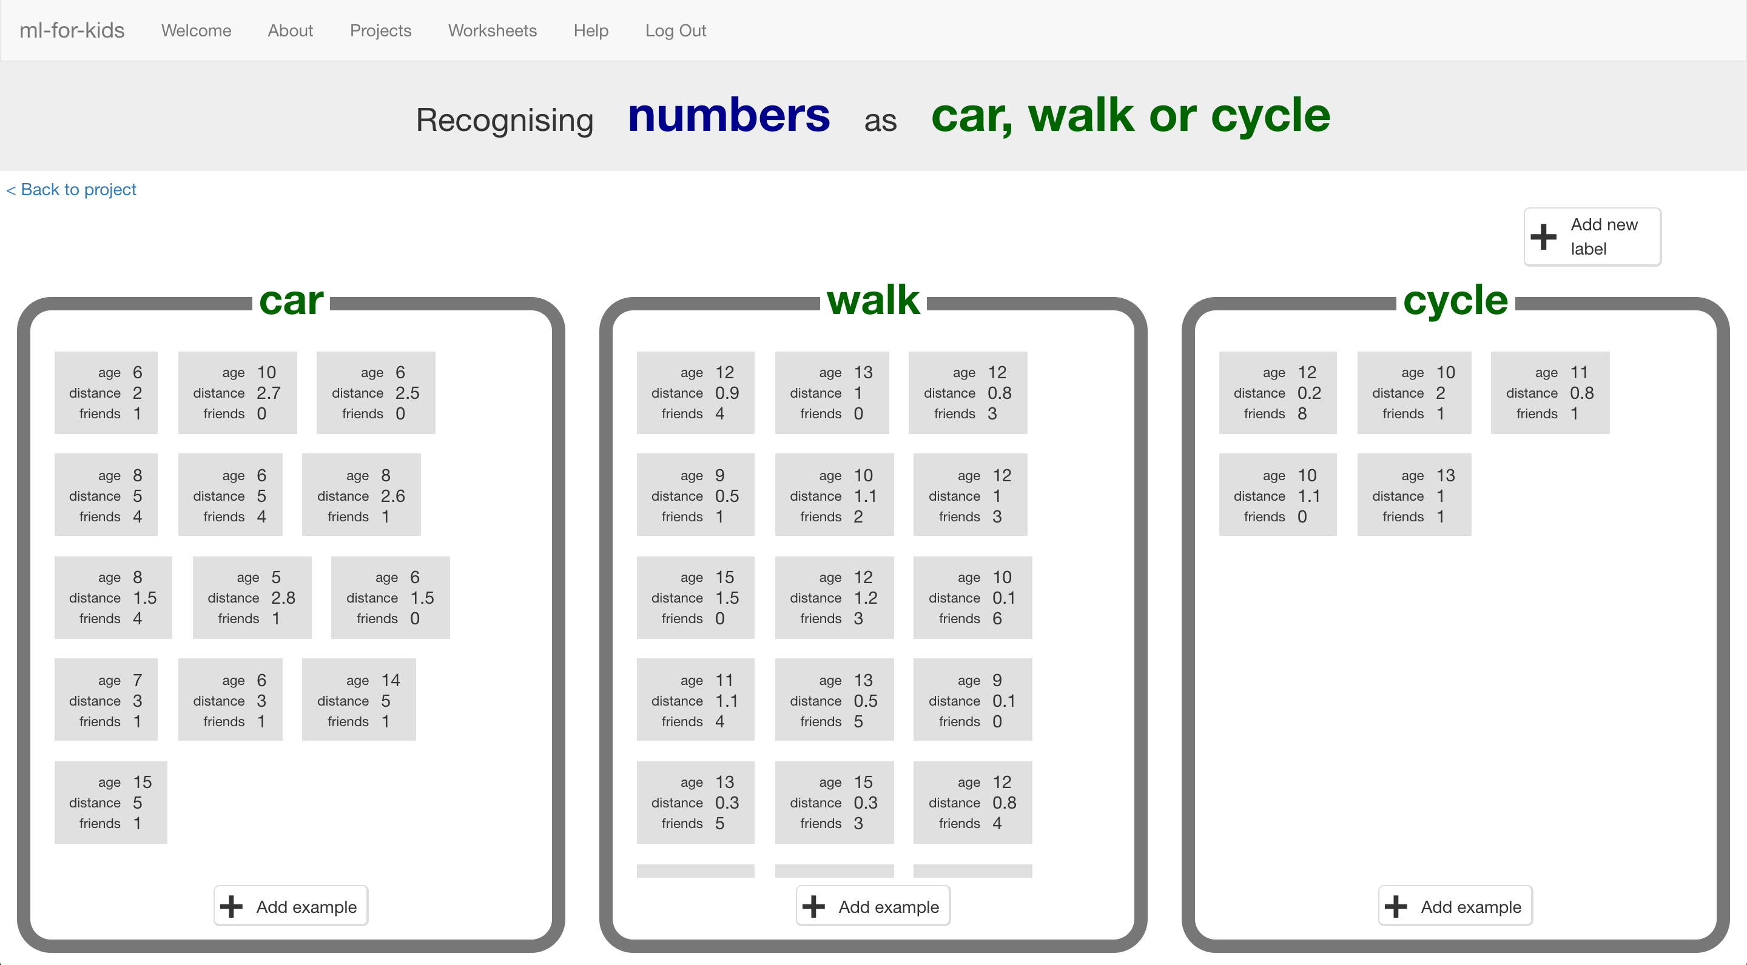

This project worksheet is licensed under a Creative Commons Attribution Non-Commercial Share-Alike License

http://creativecommons.org/licenses/by-nc-sa/4.0/

1. 在開始之前，你需要先對同學做一個調查，能問到越多人越好！

For this project, you will need to do a survey with your classmates. The more people you can ask, the better!

1. 想2~3個跟上學交通方式有關的題目來問同學。注意每題題目都是要讓人可以用數字回答的

*在這份學習單中，我們使用的問題是：*

*\*年紀（幾歲）*

*\*距離（從家到學校有多遠，單位：公里）*

*\*兄弟姐妹的數量或者住在家附近的學校朋友數量*

*你可以選擇自己想題目，只要是以數字作答的題目都行。*

*要選擇可能跟影響交通方式有關的題目。*

Write 2 or 3 questions you could ask your classmates that could affect how they travel to school. You need questions that they can answer with a number.   
*For the rest of this worksheet, we’ll use:   
* Age (in years)  
* Distance (miles from home to school)  
* Number of siblings or school friends who live nearby  
But you can choose your own values. Make sure that they are numbers, and pick things that could possibly have something to do with their journey to school.*

1. 設計調查表格並開始訪問同學

*除了問你設計的題目外，也要記得問他們上學的交通方式。*

*訪問越多人越好，如果可以問到不同班級甚至不同年級的人更好。*

Draw up a table to collect the results, and then go do your survey.   
*Remember to ask how they travel to school as well as your questions.  
The more children you ask, the better. If you can ask children from different classes and years, even better.*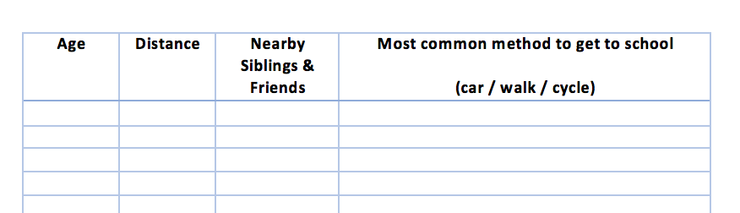

1. 當你完成調查後，我們就可以開始訓練電腦了。

搜尋網頁：<https://machinelearningforkids.co.uk/>

點選“**Get started**”按鈕

Once you’ve collected answers from as many children as possible, it’s time to use this to train the computer.   
Go to <https://machinelearningforkids.co.uk/> in a web browser and click on “**Get started**”.

1. 點選“**Log In**”按鈕並登入系統

*如果你沒有帳號，請你的老師幫你建立一個帳號。*

*如果你不記得你的帳號或密碼，請你的老師幫你重新設定一次*

Click on “**Log In**” and type in your username and password  
*If you don’t have a username, ask your teacher to create one for you.  
If you can’t remember your username or password, ask your teacher or group leader to reset it for you.*

1. 點選上方清單中的 **”Projects”** 按鈕

Click on “**Projects**” on the top menu bar

1. 點選 “**+ Add a new project**” 按鈕

Click on the **“+ Add a new project**” button.

1. 將你的專案命名為 “journey to school”並設定成辨識 “**numbers**”類別

Name your project “journey to school” and set it to learn how to recognise “**numbers**”  
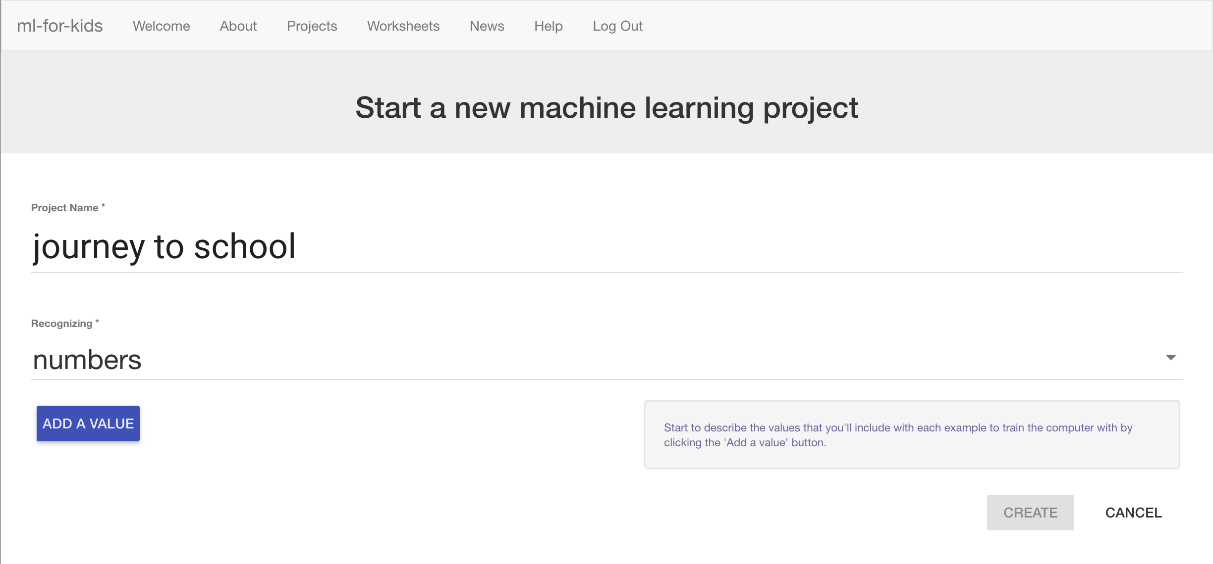

1. 點選“**Add a value**”按鈕，命名為“age”，並選擇類別“number”，

再點選“**Add a value**”按鈕，選擇類別“number”，並命名為“distance”，第三次選擇類別“number”，並命名為“friends”。

到目前為止，你的畫面應該跟下方類似。

點選“**Create**”按鈕。

*三個方框的名稱(age, distance, friends)要依據你設計的問卷做修改，但不要列入交通方式，那個之後才會用到*

Click “**Add a value**”, name it “age” and make the type “number”.   
Do this again for a “number” value called “distance”.   
Do it a third time for a “number” value called “friends”.   
Click “**Create**” when it looks like the picture below. *You should use the values you used in your survey, but don’t include the actual journey to school method. We’ll get to that next.*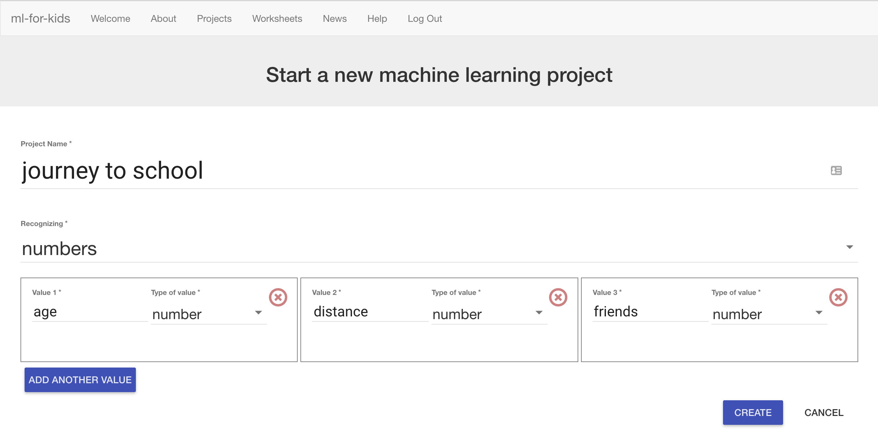

1. 你會在專案清單中看到“**journey to school**”，點選此專案

You should now see “journey to school” show up in the list of your projects. Click on it.  
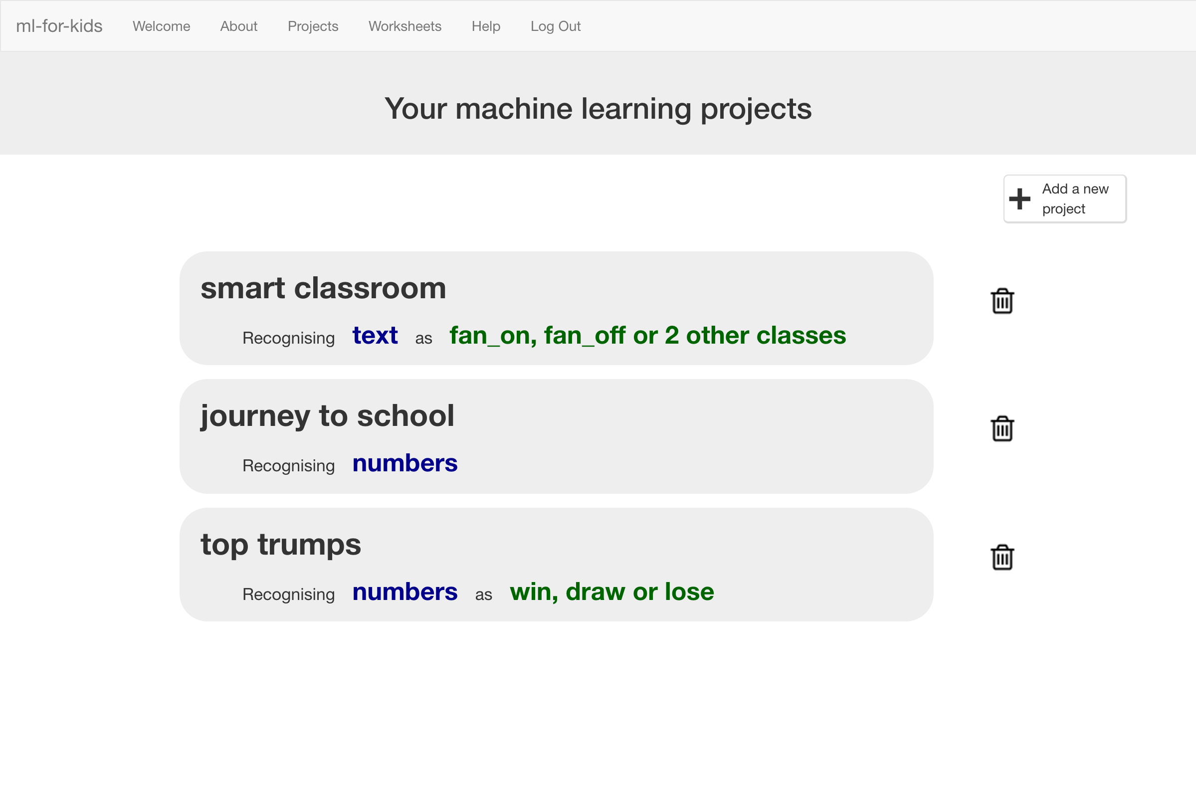

1. 點選 **”Train”** 按鈕，現在我們要開始把問卷調查結果告訴電腦

Click on the **Train** button to start giving your survey results to the computer.   
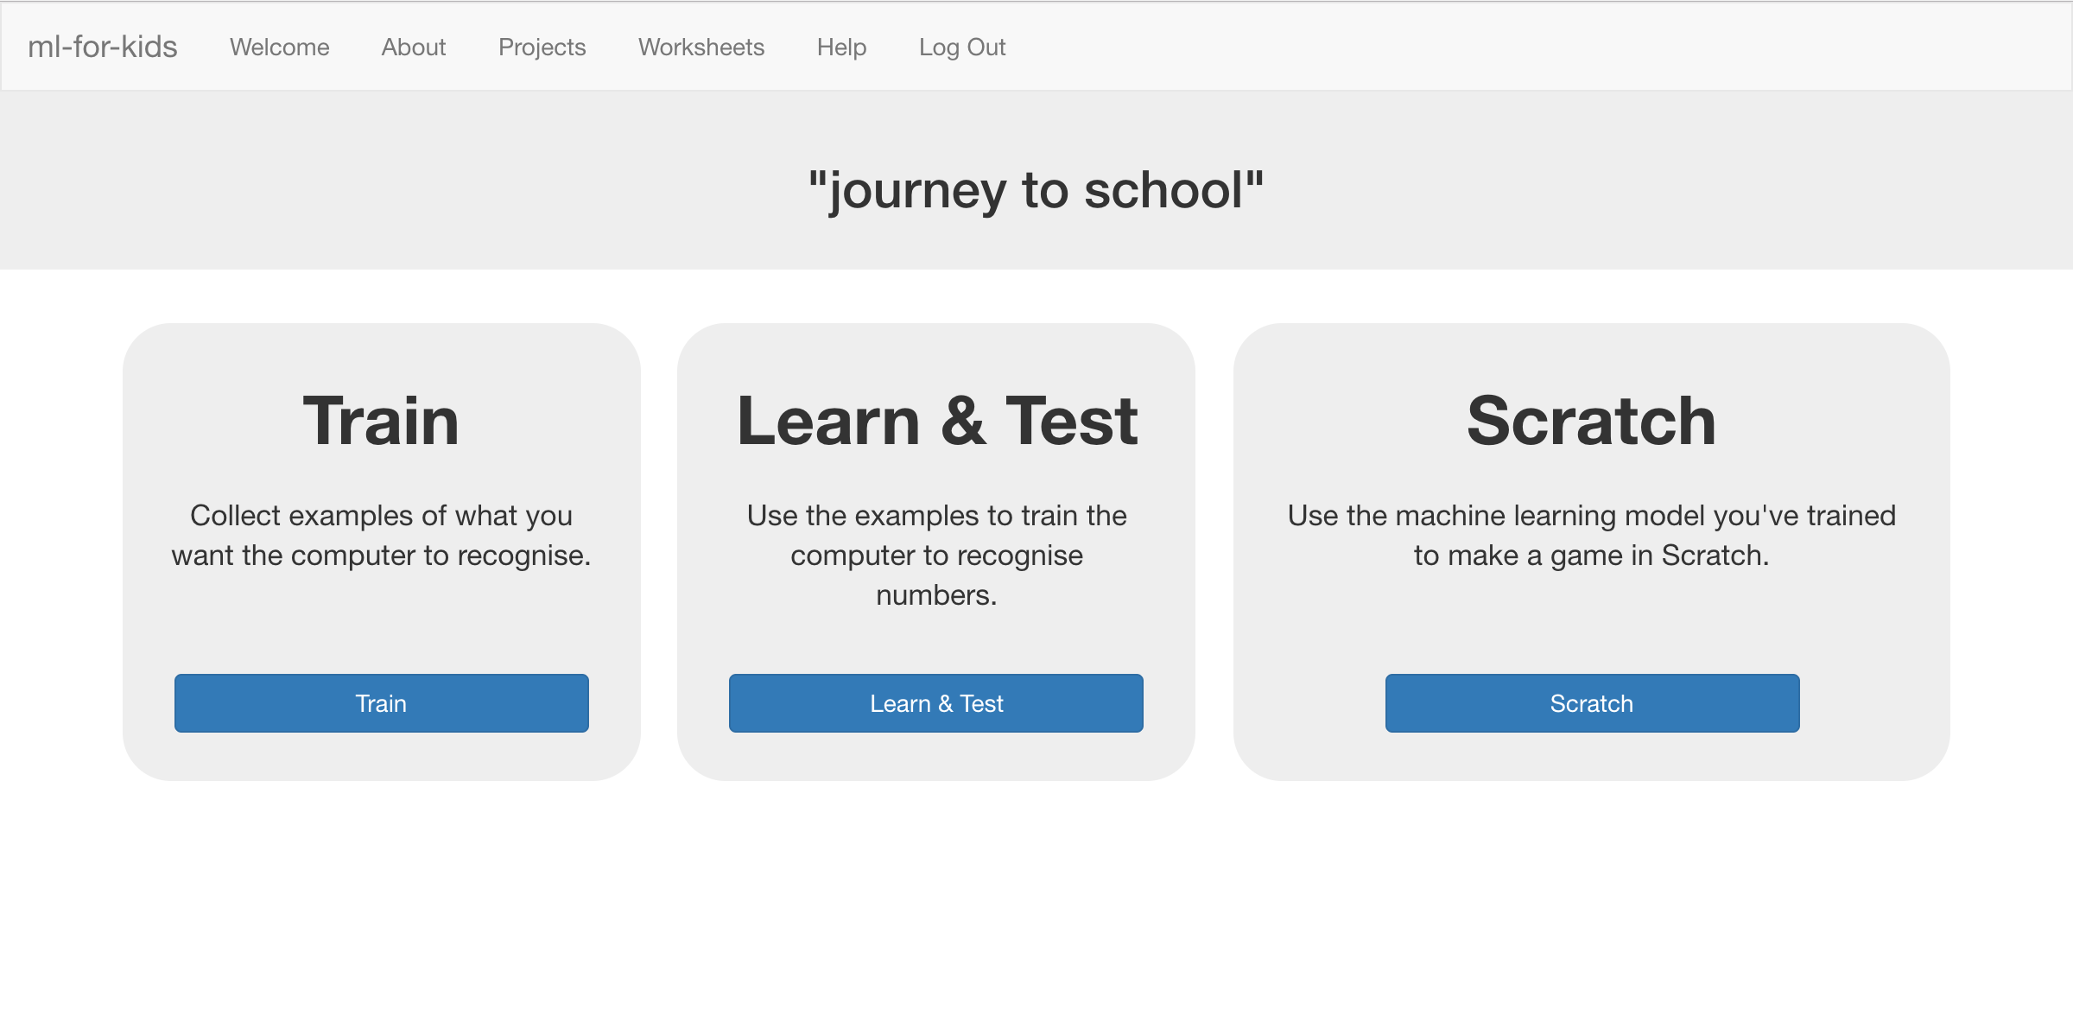

1. 點選 “**+ Add new label**”按鈕，建立一個叫“car”的方框，

再建立兩個方框，分別命名為“walk”和“cycle”。

*如果你的調查結果不是上面三種方式，將方框名稱改成你問到的結果*

Click on “**Add new label**” and create a bucket called “car”.   
Do it again and create a bucket called “walk”. Do it again for “cycle”.   
*If you used different options in your survey, use those names instead.*   
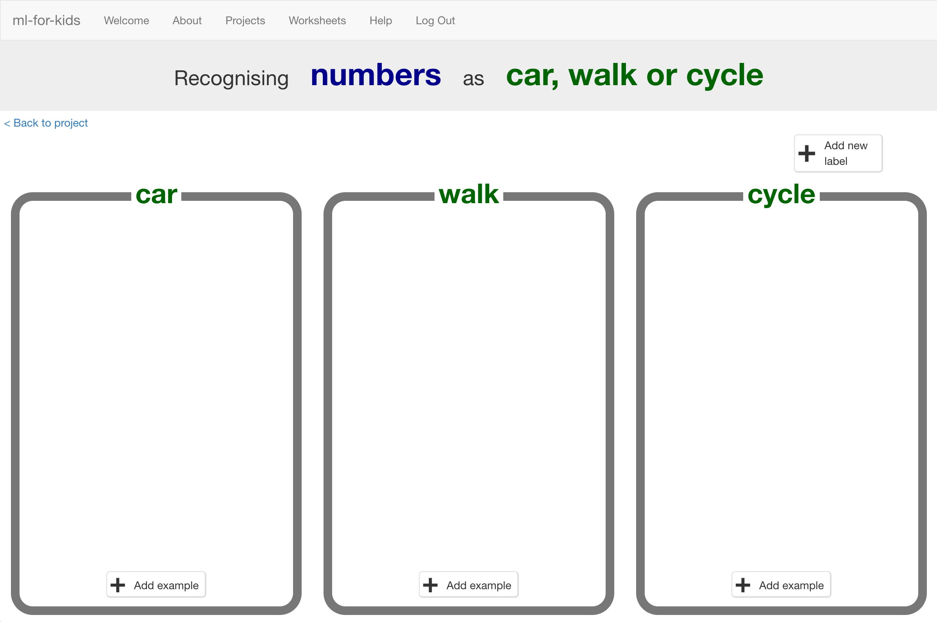

1. 點選“car”方框中的“**Add example**”按鈕，輸入一個搭車上學的受訪者訪問結果

Click on the “**Add example**” button in the “car” bucket and then type in the first survey result for someone who travels by car.   
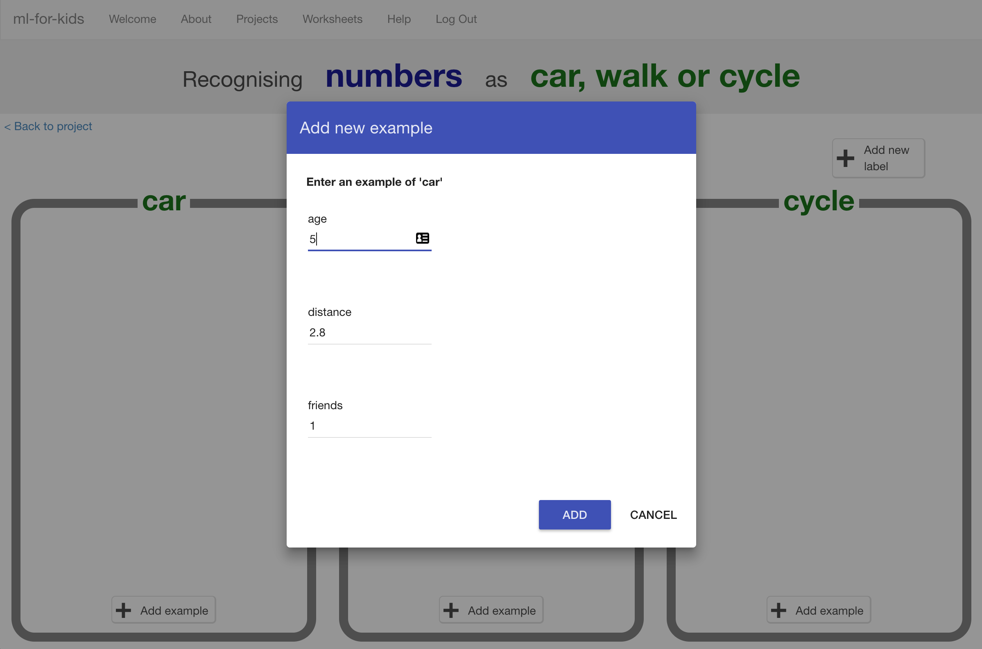

1. 重複上述步驟直到輸入全部受訪者的調查結果

Keep going until you’ve entered all the survey results.   
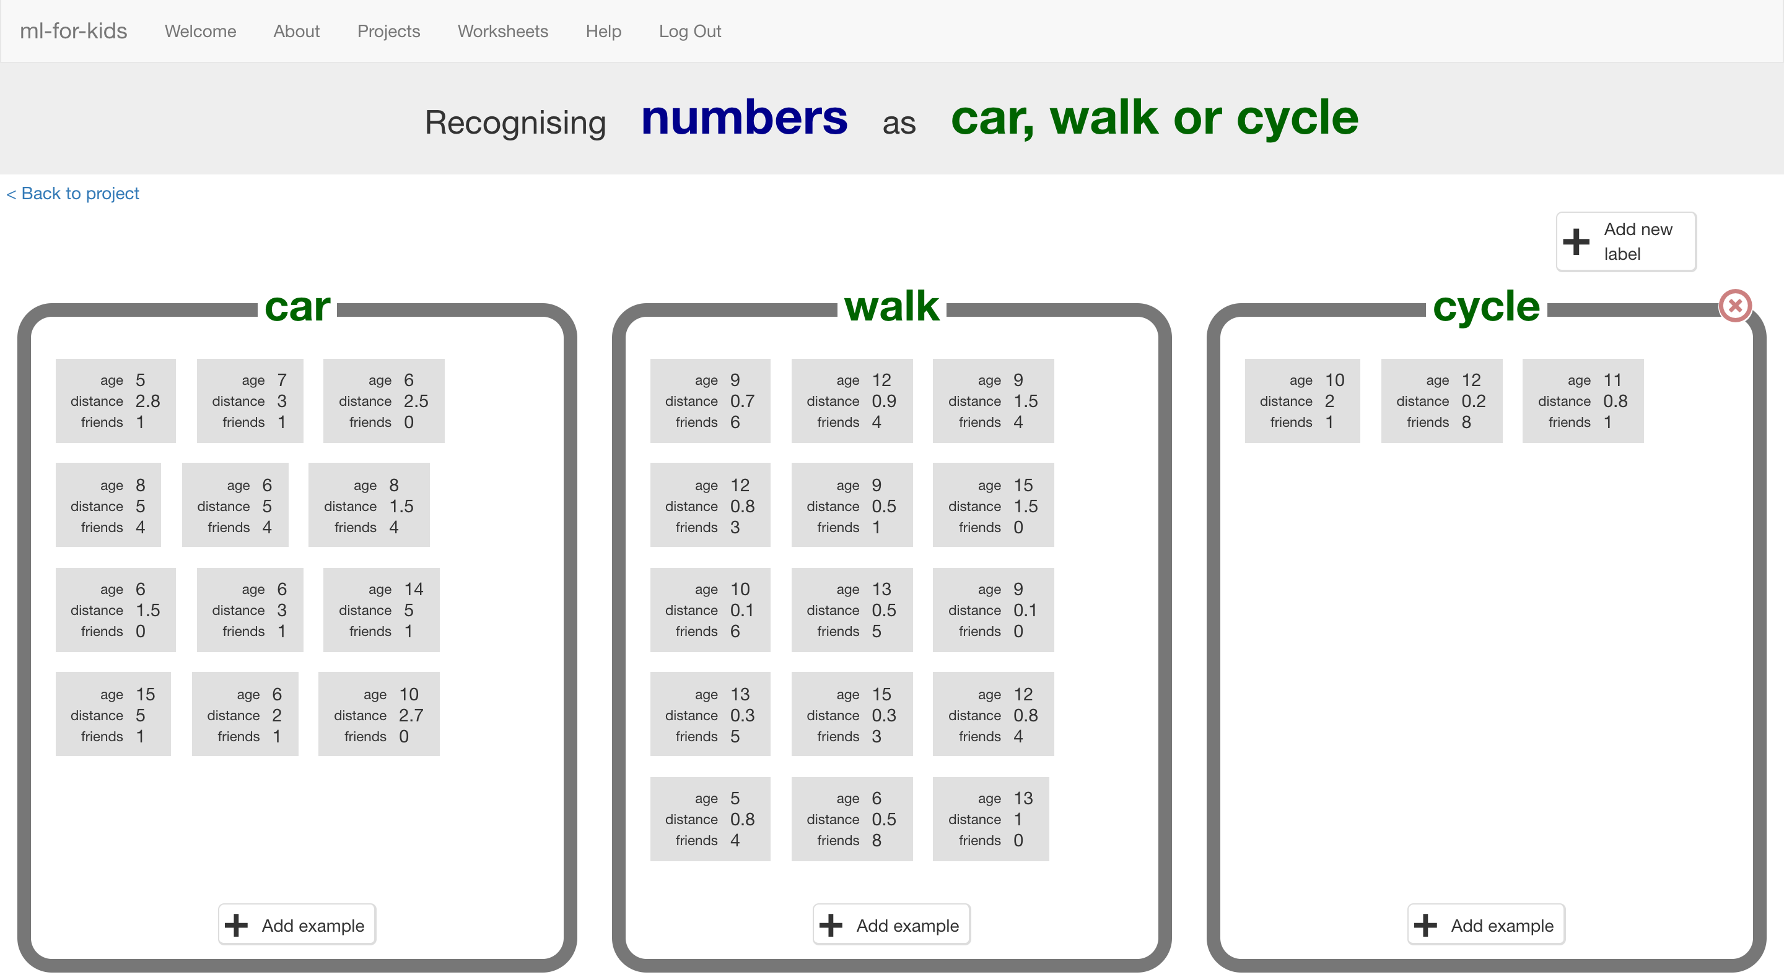

1. 點選“**< Back to project**”，再點選**Learn & Test**

Click on the “**< Back to project**” link, and this time click on **Learn & Test** to use your examples.

1. 點選**Train new machine learning model。**

訓練模型會需要一些時間。

Click on the **Train new machine learning model** button  
*It should only take a few seconds to train.*   


1. 當訓練完成後，會出現一個文字框

使用這個來測試模型，輸入個別數值後點選***Test***

Once training has finished, a Test box should appear.   
Use this to test your model.   
*Enter the values into the Test text boxes and press* ***Test****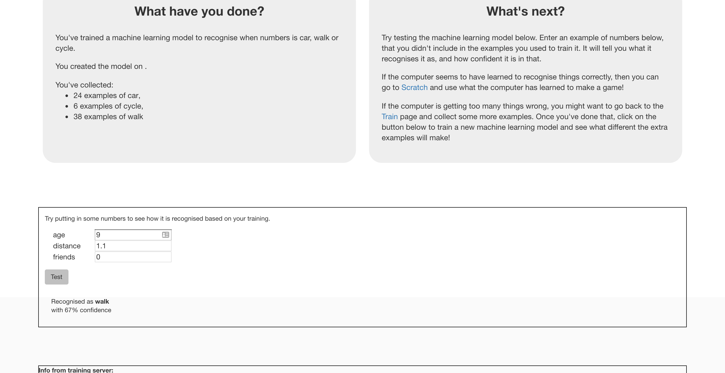*

1. 繼續測試並試著找出電腦從訓練資料裡發現了哪些共通模式

*如果你把年紀設高一點，電腦會比較容易判斷成搭車上學嗎？*

*如果是，電腦是把哪個年齡當成改變交通方式的轉折點呢？*

Keep testing to try and work out the patterns that the computer has seen in your survey data.   
*As you make the age higher, does the computer think walking becomes more likely than going by car?   
If so, what’s the age where the computer seems to have seen the change?*

**到目前為止，你做了哪些事情？**

**What have we done so far?**

你使用交通方式問卷調查結果來訓練一個機器學習模型

You’ve trained a simple machine learning model using numbers from a travel survey.

你建立了一個『預測模型』(predictive model)，會這樣取名是因為我們使用這種模型進行預測

You’ve created a “predictive model” – called that because we use models like this to make predictions.

你可以使用這個模型來預測一個已知年紀、從家到學校距離的人走路上學的可能性有多高

You could use this model to make predictions for how likely someone is to walk to school if you know their age and how far they live from school.

但，預測的準確度有多高呢？

But how accurate are the predictions?

1. 點選“**< Back to project**”按鈕回到**Train**頁面

Click on the “**< Back to project**” link and then go back into the **Train** page.

1. 選擇一個你先前輸入的調查結果，然後，刪掉它

*刪掉資料之前請先確認你有將這些資料記下來，我們之後會用到。*

*移動滑鼠至要刪除的資料，點選紅色叉叉以刪除資料*

Choose **one** of the survey responses you entered earlier, and delete it.   
**Make sure you write down all of the values for the example you are deleting before you delete it.** We’ll need the values in a minute.  
*Hover the mouse pointer over it, until the red cross appears. Click on that red cross to delete the example.   
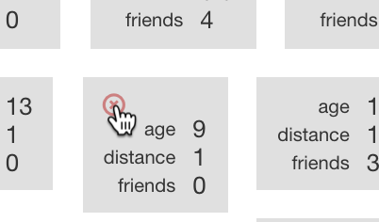*

1. 點選“**< Back to project**”按鈕回到**Learn & Test**頁面

Click on the “**< Back to project**” link and then go back into the **Learn & Test** page.

1. 點選**Train new machine learning model**

Click on **Train new machine learning model** again.  
*You might need to scroll down – the button is at the bottom of the page.*

1. 模型訓練完畢後，在**Test**的方框裡輸入你剛才刪掉的資料

你知道這筆測試資料的正確答案，比較電腦的預測結果跟正確答案，電腦回答正確嗎？

Once the new model has trained, enter the values that you deleted into the **Test** boxes.   
You know what the right answer for this is – it’s the bucket that you deleted this example from.   
Compare the computer’s prediction with the right answer.   
Did the computer get it right?

**到目前為止，你做了哪些事情？**

**What have we done so far?**

你測試了預測模型以觀察模型的正確度

You’ve tested your predictive machine learning model to see how accurate it is.

首先你刪除了一筆訓練資料，這表示你使用了電腦不曾看過的資料來測試

（如果你使用電腦曾經看過的資料來測試，那就無法證明電腦是否真的是自己學習並預測結果）

By deleting the example from the computer’s training first, it means you tested it by asking it for the answer to a question it hadn’t seen before.

(If you test it on an example that it has seen before – that it has had to learn from in it’s training – then you can’t really tell if the computer has learned how to work out the answer for itself.)

但這個測試可信程度有多高？

But how fair a test was it?

你是否選了一個很簡單的題目？（比如挑了一個家裡離學校非常遠的人）或是選了一個很難的題目？

Did you choose a really easy example? (Like a student who lives a really really long way from school!)

Or did you choose a really hard example?

該怎麼挑選題目才能讓測試變得更公平呢？

How could you have chosen an example to make it fair?

**延伸活動**

**Ideas and Extensions**

現在你已經完成了這個專案，要不要試試下面的點子？或者，自己想一個？

Now that you’ve finished, why not give one of these ideas a try?

Or come up with one of your own?

**在Scratch中使用這個模型**

**Try using this in Scratch**

你能想出一個遊戲，在遊戲中使用模型來預測人們如何上學嗎？

Can you think of a way to use the computer’s ability to predict how people travel to school in a game?

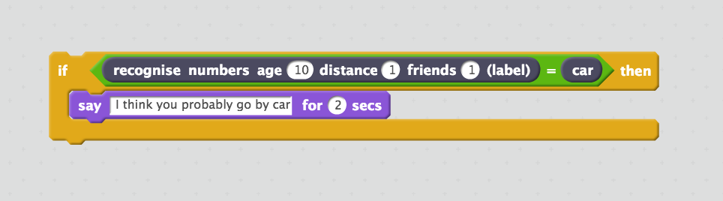

**測試更多筆資料**

**Try bigger tests**

與其只從訓練資料中刪除一筆，試試看拿更多範例資料做測試

Instead of just deleting one example from the training data and using that to test, try using more examples.

你覺得應該要拿多少筆資料來測試呢？

How many do you think you should use for testing?

如果測試資料太少，就無法確認模型到底有多好

如果測試資料太多，可以用來訓練電腦的資料就太少了

If you use too few to test, you can’t be sure how good the computer is.

If you use too many to test, you’re reducing how many examples the computer has to actually learn from.

**問卷調查結果範例**

**Example survey results**

沒辦法做問卷調查嗎？

Not able to run a survey?

別擔心！下面是我們調查到的一些資料，給你參考

No problem! Here are the results from a small survey that we ran.

| **Age**  **(years)** | **Distance**  **(miles)** | **Friends & Siblings nearby** | **Normal journey to school** |
| --- | --- | --- | --- |
| 9 | 0.8 | 0 | car |
| 8 | 0.9 | 0 | car |
| 6 | 1.5 | 12 | car |
| 6 | 2 | 1 | car |
| 11 | 3 | 0 | car |
| 15 | 7 | 0 | car |
| 10 | 2 | 0 | car |
| 14 | 7 | 0 | car |
| 10 | 2.7 | 0 | car |
| 10 | 3.5 | 2 | car |
| 7 | 3.5 | 1 | car |
| 6 | 2.5 | 0 | car |
| 11 | 2.6 | 1 | car |
| 8 | 5 | 4 | car |
| 9 | 1.2 | 0 | car |
| 6 | 5 | 4 | car |
| 9 | 2.3 | 0 | car |
| 8 | 2.6 | 1 | car |
| 8 | 1.5 | 4 | car |
| 5 | 2.8 | 1 | car |
| 6 | 1.5 | 0 | car |
| 7 | 3 | 1 | car |
| 5 | 1 | 0 | car |
| 6 | 3 | 1 | car |
| 9 | 1 | 0 | car |
| 6 | 1.1 | 0 | car |
| 5 | 1 | 4 | car |
| 5 | 10 | 0 | car |
| 14 | 5 | 1 | car |
| 14 | 7 | 0 | car |
| 15 | 5 | 1 | car |
| 9 | 1 | 0 | car |
| 9 | 1.1 | 0 | walk |
| 12 | 0.9 | 4 | walk |
| 6 | 0.5 | 5 | walk |
| 7 | 1 | 1 | walk |
| 8 | 0.9 | 0 | walk |
| 13 | 1 | 0 | walk |
| 9 | 1 | 0 | walk |
| 11 | 1.4 | 3 | walk |
| 11 | 1.5 | 2 | walk |
| 9 | 0.9 | 0 | walk |
| 9 | 1.1 | 0 | walk |
| 9 | 1 | 1 | walk |
| 8 | 1.3 | 0 | walk |
| 9 | 1 | 0 | walk |
| 10 | 0.9 | 1 | walk |
| 9 | 1.2 | 0 | walk |
| 9 | 1 | 3 | walk |
| 11 | 1 | 0 | walk |
| 12 | 0.8 | 3 | walk |
| 9 | 0.5 | 1 | walk |
| 10 | 1.1 | 2 | walk |
| 12 | 1 | 3 | walk |
| 15 | 1.5 | 0 | walk |
| 12 | 1.2 | 3 | walk |
| 9 | 1.3 | 0 | walk |
| 10 | 0.1 | 6 | walk |
| 11 | 1.1 | 4 | walk |
| 9 | 1.25 | 1 | walk |
| 13 | 0.5 | 5 | walk |
| 7 | 1.25 | 1 | walk |
| 9 | 0.1 | 0 | walk |
| 9 | 1.4 | 1 | walk |
| 13 | 0.3 | 5 | walk |
| 15 | 0.3 | 3 | walk |
| 12 | 0.8 | 4 | walk |
| 5 | 0.8 | 4 | walk |
| 9 | 1.1 | 1 | walk |
| 9 | 1.5 | 4 | walk |
| 9 | 0.7 | 6 | walk |
| 8 | 0.6 | 4 | walk |
| 6 | 0.5 | 8 | walk |
| 16 | 1 | 10 | walk |
| 9 | 1 | 2 | walk |
| 12 | 0.2 | 8 | cycle |
| 10 | 2 | 1 | cycle |
| 11 | 0.8 | 1 | cycle |
| 10 | 1.1 | 0 | cycle |
| 13 | 1 | 1 | cycle |
| 9 | 1.1 | 0 | cycle |